# Lab 7

# Get a feel of the use of Postman and engrok

This work is a continuation of lab 6. You’ll in groups of 2.

More often, when API designers do not have time to build an application to be used to test their API. This can be simulated. As a programmer, you do not need to host your application on a live sever for to test to allows other developers to access.

Although, **postman** and **engrok** have many functions, we are going to exploited at least one function in each.

Engrok – Expose your local server (the apache you have in your machine) to the internet securely.

Postman - Developers use Postman to build modern software for the API-first world. We will simulate requests and responses.

**Proceed as follows:**

Install postman

Download and save engrok somewhere in your machine

Remember in lab 6, we were forced to build another application to make an order and to check status. We won’t do that now. We will use postman to simulate such a request and receive a response and you will allow your partner to do it.

One of you – partner 1:

Ensure your machine is connected to the internet.

Ensure your server (I hope you’re using apache in xampp) is running

In your terminal, access engrok directory in your machine and execute this

Engrok http 80 //80 is the server port number. Apache’s default port number is 80 unless you change it.

You will see something like this

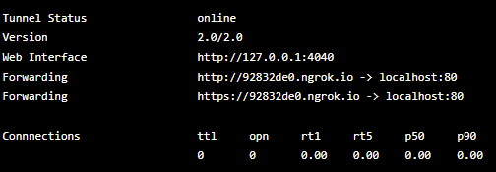

The ULR indicated as forwarding is your online engrok url of your machine. This is the URL you give to your partner.

If your PHP script is in localhost/api/v1/test.php then it will be <https://928320.ngrok.io//api/v1/test.php>

One of you – partner 2 or even a third partner or even the whole class!!

Construct a http request from postman in your machine, using this URL.

Before your fire the request, select the method you want to use (e.g. POST), data format for sending (e.g. form data, json etc.) and receiving

The data you want to send to the server can be added as key and values in postman

Note that you can also add your own key in the header (remember our API is passed in the header) (see tutorial here <https://www.getpostman.com/docs/v6/postman/sending_api_requests/requests> )

***-This lab is complete-***